Fatima Jinnah Women University

Department of Software Engineering

Cloud Computing  
Assignment no: 1

***Submitted by***

Sarosh Majeed

2023-BSE-059

5-B

***Submitted to***

Sir Waqas Saleem

**Submission Checklist**

**1. Screenshot of your Gitea repository (showing README listing names & roll numbers).**

In this task, I worked on setting up **Gitea** inside **GitHub Codespace**.  
Gitea is like a smaller version of GitHub that runs on our own server. It helps us create and manage repositories.

First, I opened the Codespace and started the Gitea server. When it was running, I opened the Gitea page in the browser.  
Then I created a **new repository** in Gitea and added a **README.md** file in it. This file had my **name and roll number** written inside.

After that, I uploaded (pushed) this README file from Codespace to my Gitea repository.  
This showed that my Gitea server and repository were working correctly.

***The screenshot shows my Gitea repository with the README file that contains my details.***

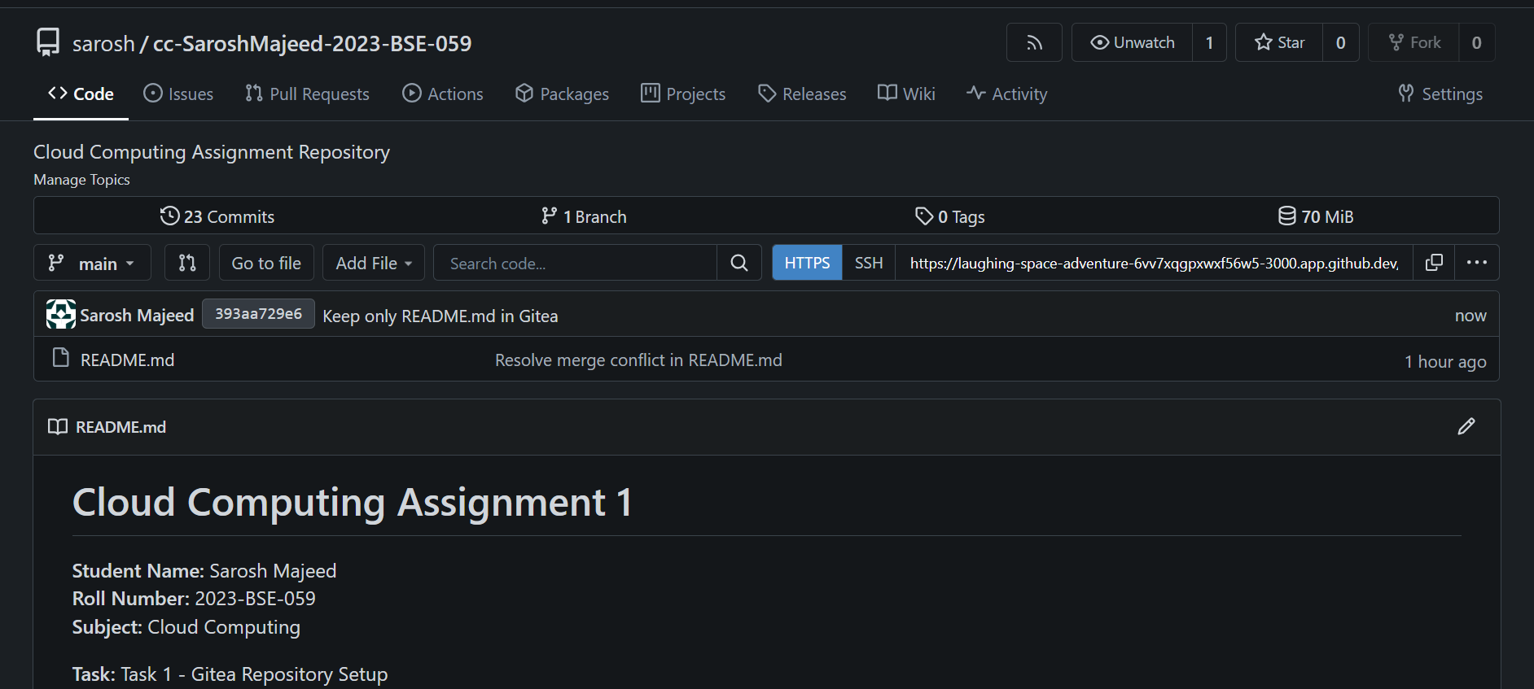

**2. GitHub assignment 1 repo link (with README and large files)**

In this task, I learned how to upload **large files (more than 100 MB)** using **Git LFS (Large File Storage)**.  
Normally, GitHub doesn’t allow files larger than 100 MB, but with Git LFS, we can store them easily.

I installed Git LFS in my repository and added **three large files** to it (each file was more than 100 MB).  
Git LFS helps by saving only a pointer in the main repository, while the actual big file is stored separately.

After tracking and committing the files, I uploaded them to my **GitHub assignment 1** repository.  
This made sure all my large files were properly stored and didn’t cause upload issues.

***The GitHub link shows the repository with the big files uploaded successfully.***

**Link :** [**https://github.com/Sarosh-Majeed/assignment-1**](https://github.com/Sarosh-Majeed/assignment-1)

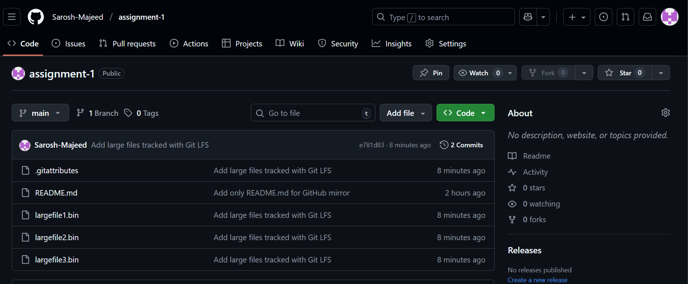

**3. Screenshot or output of git remote -v showing both remotes.**

In this task, I had to **connect my Gitea repo with GitHub** and copy (mirror) the same README file there.

I used the same project that I created in Task 1. Then I made a **new repository on GitHub** named **assignment 1**.  
After that, I connected both repositories together so that my work on Gitea could also be seen on GitHub.

When I uploaded (pushed) the README.md file, it appeared on GitHub successfully.  
This proved that both my Gitea and GitHub repositories were connected properly.

***The screenshots show that the README file is also visible on Github.***

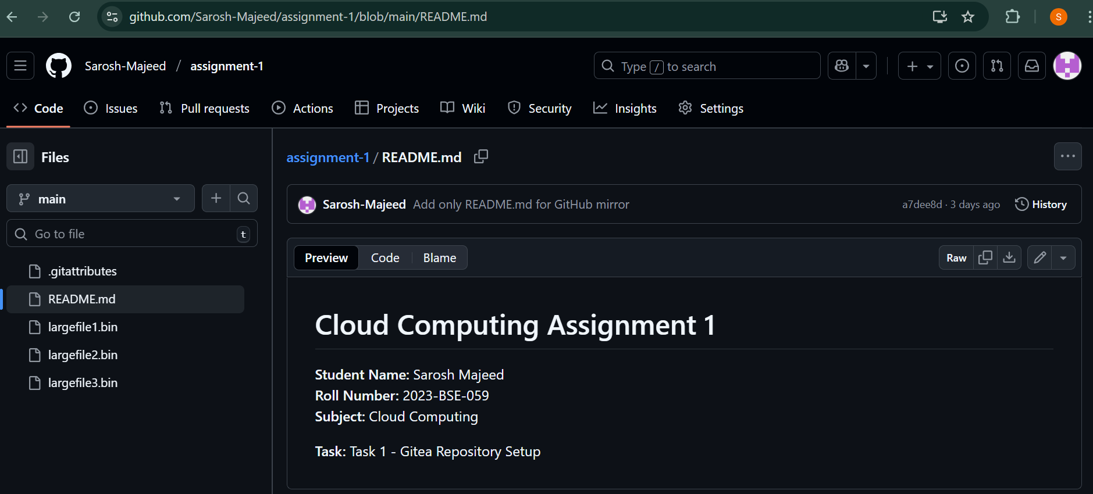

***The git remote -v output shows both “gitea” and “github” are connected as remotes.***

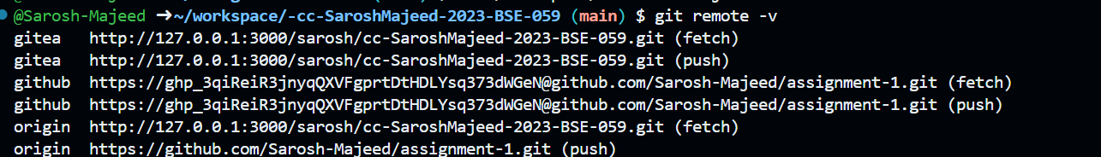

**4. GitHub Pages link to your CV/portfolio**

In this task, I made my **own online portfolio website** using **GitHub Pages**.

First, I created a new repository named **<myusername>.github.io** (for example: Sarosh-majeed.github.io).  
This special type of repository is used by GitHub to host websites for free.

Then I created a few files:

* **index.html** — for the main structure of my website
* **style.css** — for the design and colors of my website

I wrote my **personal information, education, and skills** in the HTML file and styled it with CSS to make it look nice.  
After completing it, I uploaded all these files to my GitHub repository.

Finally, GitHub automatically published my CV as a **live website**, which can be opened using a link like <https://sarosh-majeed.github.io>.

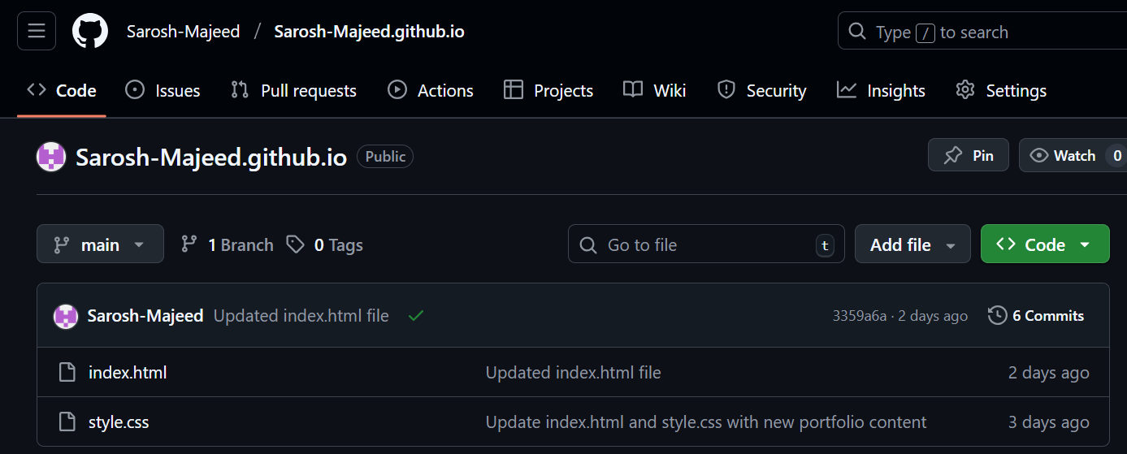***The screenshot shows my repository files that are used to make the webpage.***

***The link shows my live portfolio/CV website made with HTML and CSS.***

**Link :** [**https://sarosh-majeed.github.io/**](https://sarosh-majeed.github.io/)



      